Tutorial 7

Advanced Sort Merge Sort

1. Using Merge Sort binary tree, trace the execution of merge sort with the following list of numbers:
   1. 4, 7, 1, 8, 3, 2, 6, 5 (in ascending order)
   2. 5, 2, 7, 8, 1, 4, 6, 3 (in descending order)

**Part A:**

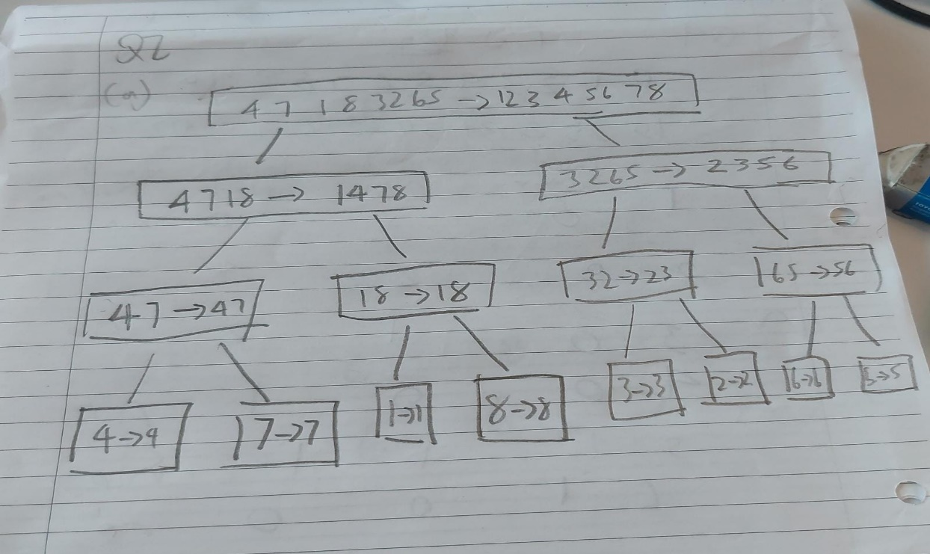

**Part B:  
  
